

Stuart Tarshis
Tarshis & Hammerman
118-35 Queens Boulevard
Forest Hills, NY 11375

Dear Mr. Tarshis,

Our client, David Weiser, has commissioned Axiom Requisition Copy Service to obtain records on Malcolm Bricklin for use in the case of Bricklin vs. JMC Floor Covering. NYC Fire Department/EMS is requiring their request form be filled out with specific information in order to search for records. They require the following information: Incident Date, Time, Location, Borough , Hospital taken to, Name of the Actual Ambulance service that transported the patient, ACR # (Ambulance Care Report) and PCR # (Pre-Hospital Care Report).

To facilitate this please find enclosed their request form. Also, if you have not already provided an original, signed & notarized authorization please include the authorization when you return the request form.

Please have your client fill in this form at your earliest convenience, and return to:
Axiom Requisition Copy Service
2869 Jolly Rd
Okemos, MI 48864
(877) 886-5090 Fax (517) 886-4116

Thank you for your cooperation in this matter.

Sincerely,
Axiom Requisition Copy Service

Vicki Lintemuth
Vicki Lintemuth
Account Executive

Order No. 01-24167-002
A Division of The Axiom Group Inc.  2869 Jolly Road  Okemos, MI 48864 | www.AxiomCopy.com | 517.886.5099  Toll Free 877.886.5090  Fax 517.886.4116
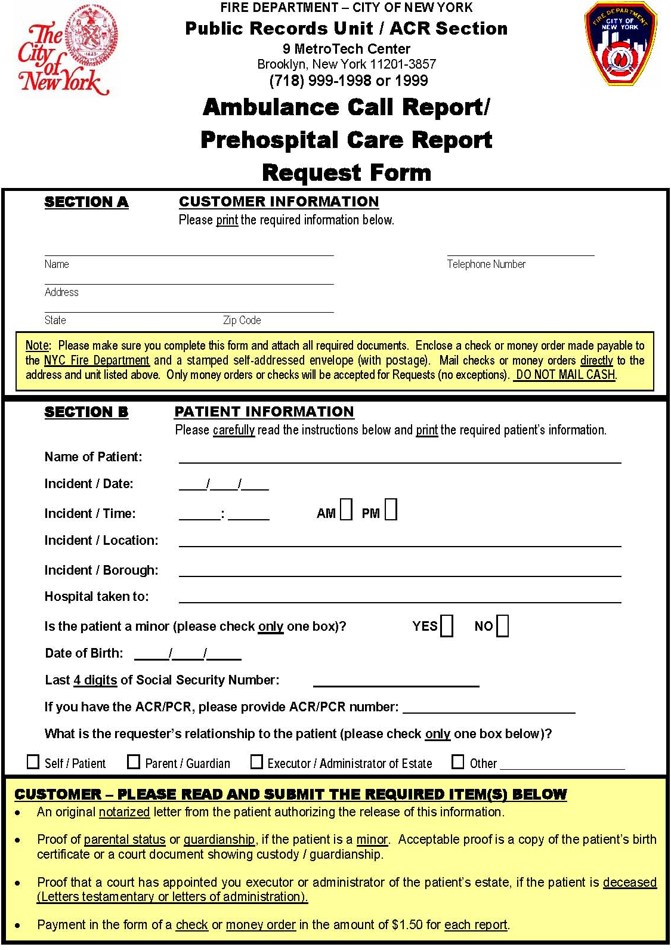
03/09/1939
XXX-XX-0010

Order No.: 01-24167-002
Axiom Requisition Copy Service (877) 886-5090
2869 Jolly Rd
Okemos, MI 48864
Malcolm Bricklin

Defense Attorney
X
Axiom Requisition Copy Service
2869 Jolly Rd, Okemos, Michigan 48864
517.886.5099 – 877.886.5090 toll free – 517.886.4116 facsimile

ADDITIONAL PATIENT INFORMATION REQUIRED

TO: Stuart Tarshis
OF: Tarshis & Hammerman
FROM: Vicki Lintemuth, Account Executive
OF: Axiom Requisition Copy Service
*****

CUSTODIAN: NYC Fire Department/EMS
PATIENT: Malcolm Bricklin
RE: Bricklin vs. JMC Floor Covering
FILE NO.: 14-00529355
*****

The following information is required so that this location can search for the ambulance transport records being requested:

Name of Actual Ambulance Service that Transported Patient:
______________________________________________________________________
ACR# (Ambulance Care Report) and/or PCR# (Pre-Hospital Care Report):
______________________________________________________________________

Should you have any questions, please feel free to call our office at (877) 886-5090.

Order No. 01-24167-002

